SFTP Setup In UMG Environment

For SFTP we need to have the following:

1. Create SSH keys (Public & Private) for the tenant.
   1. The keys should be named based upon the tenant code. Say “user1”.

ssh-keygen -t rsa -C "*<tenantName>@example.com*"

# Creates a new ssh key, using the provided email as a label

# Generating public/private rsa key pair.

# Enter file in which to save the key (*<storagePath>*/id_rsa): *<location>/<tenantCode>*

# Enter passphrase (empty for no passphrase): *<tenantPassPhrase>*

#Enter same passphrase again: *<tenantPassPhrase>*

1. Put the public key into the FTP server and link the public key to the user. The screen shot is only representational and may vary depending upon the FTP server in use.

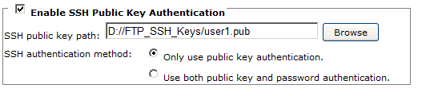

1. Create a new folder “Key” for each tenant under the “sanpath/<tenantCode>/batch” location.
2. Put the private key for the tenant under the newly created Key folder.
3. Make sure the folder structure for the tenant san-location should resemble.

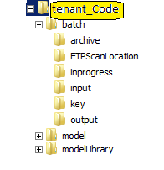

1. Run the data setup query for the tenant in umg_admin schema.
2. Login to UMG Admin screen and navigate to Tenant Configuration screen. Make sure all FTP parameters are updated with proper values. These values are fetched from umg_admin.tenant_config table.
3. On the tenant configuration screen, select FTP (checkbox) and save the configuration. This would deploy the SFTP flow for the tenant.
4. Use a FTP client to put input files in the FTP input location.
5. After processing the files would appear in the output and archive folders.